RNN and RI joint research on the implementation of "72 Targets" of APDDP
Hisao Sato, Chair, RI Social Commission for AP
(Professor, Japan College of Social Work, jcsw-hisao.sato@nifty.ne.jp)
Naoko Iwata, Member, RI Social Commission for AP
(Assistant Professor, Okinawa International University, iwata@okiu.ac.jp)

Introduction
Social Commission for Asia and Pacific of Rehabilitation International and RNN (Regional NGO Network) for APDDP have jointly started a research work on the implementation of "the 72 targets" for the APDDP.
“The 72 targets” is a very unique and important document to monitor the implementation of the Agenda for Action of the APDDP. The full title of the document is “Targets and Recommendations for Implementation of the Agenda for Action for the Asian and Pacific Decade of Disabled Persons”. It was decided at the first inter-governmental review meeting convened by ESCAP to monitor the progress of the implementation of the Agenda for Action in Bangkok in June 1995 in which many RNN members attended as observers and took part in the discussion. It was officially adopted by the ESCAP General Assembly in April 1996. The Agenda for Action has 12 areas, which are further broken down into 72 concrete and detailed targets with a specific dead line year. Thus it is expected to be used to monitor progress. But it seems no country nor ESCAP itself has used it for evaluation purpose.
Although the ESCAP and member governments have the primary responsibility to monitor the implementation, we NGOs can do something to encourage the GOs. We would like to collect opinions from NGOs on the implementation of the 72 targets, to analyse them and look for the future action needed. It would not be easy work, but the first step needs to be taken as we are approaching the end of the Decade.
Method
Our research tries to collect NGO’s evaluation. Respondents to the questionnaire are one of the board members of national member organizations of RNN in each country. The questionnaire was also sent to representative NGOs in countries with no RNN member organization. Total number of questionnaires sent was 22 including 15 RNN members. The 22 countries are Bangladesh, Hong Kong, Indonesia, Japan, Korea, Nepal, Pakistan, Philippines, Thailand, Malaysia, Australia, New Zealand, Vietnam, Myanmar, Cambodia, Mongolia, Iran, Singapore, China, Fiji, India and Laos. Collected questionnaires were 10 by the time of organizing this report. (Due to our insufficient communication a response from a government staff in Mongolia was collected and included in this report. We thank her cooperation. The number of response is increasing during Campaign 99).
Questionnaires were sent in September 1999 and collected by November 1999.
Only 55 targets with planned year 1998 or earlier out of 72 targets are included in this survey. We asked to evaluate each targets whether it had been implemented BY NOW (the time of filling this questionnaire) or not, regardless of the planned year of the target.
Respondents were asked to evaluate each target by choosing one of 4 implementation levels:
1. no or few measures have been taken (0-4%)
2. slightly implemented (5-49%)
3. fairly implemented (50-95%)
4. fully or nearly implemented (96-100%).
Only personal opinions were collected rather than officially decided opinions. We asked for reports based on nation wide viewpoint rather than reflecting the community of the respondent.

Results
Most implemented areas:
6 Education (average 2.5)
9 Rehabilitation Services (average 2.5)

Least implemented areas:
4 Public Awareness (average 2.0)
5 Accessibility & Communication (average 2.1)
We need to take seriously the fact that the least implemented area is Public Awareness because this is the most basic area for the Agenda for Action.

Now we look at individual targets.
Most implemented targets:
2.6 Review laws related to customs duties and amend (average 2.9)
5.5 Incorporate access provisions for PWD into existing building by-law (average 2.8)
8.1 Identify the major factors of causes (average 2.7)
10.2 Exempt customs on import of assisted devices (average 2.7)

Least implemented targets:
4.4 Issue first day covers & commemorative stamps (average 1.3)
5.4 Include barrier-free design in the curricula for architect training (average 1.8)
We do not need much money to implement these targets, and only need “will” to do.

Legislation is important:
The answer from Singapore suggests the importance of legislation:
“Accessibility & Communication: 5.1(1995) = 4, 5.2(1995) = 4, 5.3(1995) = 4, 5.4(1995) = 4, 5.5(1997) = 4, 5.8(1998) = 3
Singapore has amended the Building Control Regulations in 1989 to require all new buildings which people with disabilities have or may reasonably be expected to have access, to be designed in accordance with the Code on Barrier-Free Accessibility in Buildings. The Accessibility Code was first published in 1990 and was revised in 1995 with the assistance of the Handicaps Welfare Association, a self-help organization for people with disabilities.

Difference in “levels of implementation” reported from each country:
Japan (average 3.6)
P.R. China (average 3.1)
Bangladesh (average 1.3)
Nepal (average 1.3)
These results seem to reflect actual reality to some extent and subjective ness of the respondents also to some extent. Each of the 72 targets consists of several sub targets and are not easy to be evaluated by a single scale. Moreover it includes many general words such as “effective”, “appropriate”, “adequate”, “suitable”. Thus problems exist not on the side of the respondents but in the 72 Targets itself and our 4 points scale to evaluate the level of implementation. We need to work further to improve the reliability of the scale and the way of research towards next steps.

Discussion and Proposals
The RNN national member organization should prepare a country report on “the implementation of the 72 targets” for the Campaign 2000 in Bangkok or 2001 in Vietnam using the scale we used in this research. The report should not only give the numeric rating of the level of implementation for each target, but also give some narrative comments explaining the reasons of the rating. We can use these comments to prepare a guideline for evaluation. We need a more standardized and reliable tool to monitor the APDDP.
The 4 points scale and the 72 Targets would be best used in each country rather than AP region as a whole. It will not give a reliable comparison. Rather, a series of consensus conferences should be organized by NGOs in each country to evaluate the progress of the APDDP and the scale and the 72 targets should be used as tools. The results of the conference would be used for the country report mentioned above.
As the Decade is approaching the last stage, we need to make best use of the 72 Targets. We appreciate your suggestions and cooperation. Thank you.
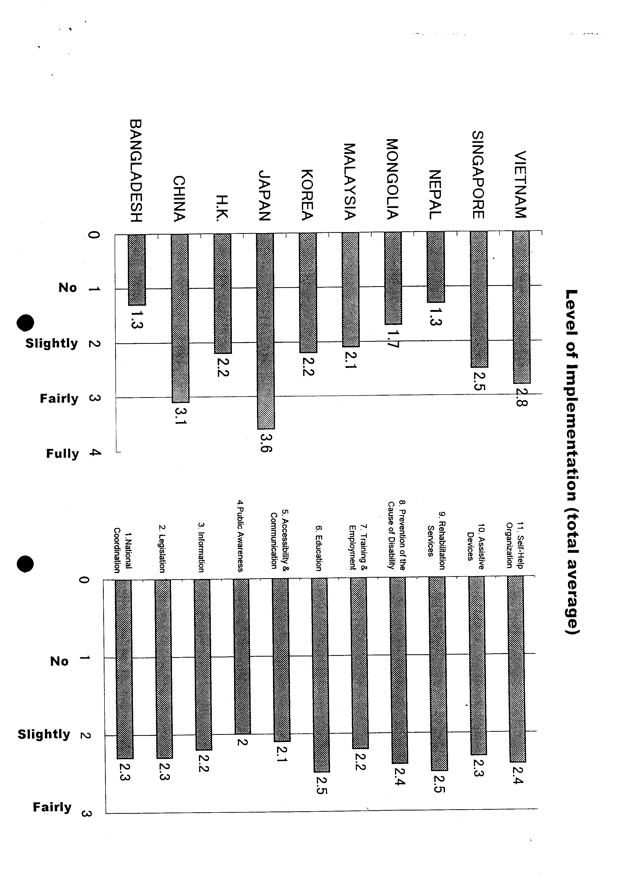
Evaluation of the Targets
Targets | BA | CH | HK | JA | KO | MA | MO | NE | SI | VI | ave
1. National Coordination
1.1 Establish National Coordination Committee (NCC) | 3 | 4 | 3 | 3 | 3 | 3 | 2 | 1 | 1 | 3 | 2.6
1.2 Establish NCC executive committee | 2 | 4 | 1 | 3 | 3 | 3 | 2 | 1 | 1 | 3 | 2.3
1.3 Formulate a national plan of action | 2 | 3 | 4 | 4 | 3 | 2 | 2 | 1 | 1 | 3 | 2.5
1.4 Prioritize poor PWD in all poverty alleviation program | 1 | 4 | 1 | 3 | 3 | 2 | 2 | 1 | 1 | 4 | 2.2
1.5 Specify the participation of PWD and for approving funds | 1 | 4 | 1 | 3 | 3 | 2 | 1 | 1 | 1 | 4 | 2.1
Average | 1.8 | 3.8 | 2 | 3.2 | 3 | 2 | 1.8 | 1 | 1 | 3.4 | 2.3
2. Legislation
2.1 Establish a suitable mechanism to examine all substantive | 1 | 3 | 1 | 3 | 3 | 2 | 2 | 1 | 1 | 2 | 1.9
2.2 Complete the process and to examine and identify laws | 1 | 3 | 1 | 3 | 4 | 1 | 2 | 1 | 1 | 2 | 1.9
2.5 Introduce a national scheme to examine and identify measure | 1 | 4 | 4 | 3 | 3 | 1 | 2 | 1 | 1 | 4 | 2.4
2.6 Review laws related to customs duties and amend | 1 | 3 | 4 | 4 | 4 | 3 | 2 | 2 | 3 | 3 | 2.9
2.7 Review and amend other taxation laws | 1 | 3 | 2 | 4 | 3 | 2 | 3 | 1 | 3 | 4 | 2.6
Average | 1 | 3.2 | 2.4 | 3.4 | 3.4 | 1.8 | 2.2 | 1.2 | 1.8 | 3 | 2.3
3. Information
3.1 Establish a national resource centre | 1 | 3 | 2 | 3 | 3 | 1 | 1 | 1 | 2 | 3 | 2
3.2 Initiate a national sample survey | 1 | 4 | 1 | 4 | 3 | 1 | 1 | 3 | 1 | 4 | 2.3
3.3 Translate the Agenda for Action into national & local languag | 2 | 4 | 1 | 4 | 2 | 3 | 3 | 1 | 1 | 2 | 2.3
Average | 1.3 | 3.7 | 1.3 | 3.7 | 2.7 | 1.7 | 1.7 | 1.7 | 1.3 | 3 | 2.2
4. Public Awareness
4.1 Ensure that mass media feature Decade-related issues | 2 | 4 | 2 | 3 | 2 | 2 | 2 | 1 | 2 | 4 | 2.4
4.2 Initiate review of educational & functional literacy materials | 1 | 3 | 1 | 4 | 2 | 3 | 2 | 1 | 2 | 3 | 2.2
4.4 Issue first day covers & commemorative stamps | 1 | ? | 1 | 1 | 2 | 2 | 1 | 1 | 1 | 2 | 1.3
4.5 Include disability issues and policies relating to medi | 1 | 4 | 2 | 4 | 2 | 1 | 2 | 1 | 2 | 2 | 2.1
4.6 Establish an effective monitoring mechanism | 1 | 3 | 2 | 3 | 2 | 2 | 2 | 1 | 1 | 3 | 2
Average | 1.2 | 3.5 | 1.6 | 3 | 2 | 2 | 1.8 | 1 | 1.6 | 2.8 | 2
5. Accessibility & Communication
5.1 Incorporate barrier-free features as a standard requirement | 1 | 3 | 3 | 4 | 2 | 2 | 1 | 1 | 4 | 2 | 2.3
5.2 Include barrier-free features in mass transport facilities | 1 | 2 | 3 | 3 | 1 | 2 | 1 | 1 | 4 | 1 | 1.9
5.3 Make external built environments accessible | 1 | 2 | 2 | 3 | 2 | 2 | 1 | 1 | 4 | 1 | 1.9
5.4 Include barrier-free design in the curricula for architect | 1 | 3 | 1 | 2 | 1 | 2 | 1 | 1 | 4 | 2 | 1.8
5.5 Incorporate access provisions for PWD into existing build | 1 | 4 | 4 | 3 | 2 | 3 | 3 | 1 | 4 | 3 | 2.8
5.8 Make available reading material | 1 | 2 | 2 | 3 | 1 | 3 | 1 | 1 | 4 | 3 | 2
Average | 1 | 2.7 | 2.5 | 3 | 1.5 | 2.3 | 1.3 | 1 | 4 | 2 | 2.1

Targets | BA | CH | HK | JA | KO | MA | MO | NE | SI | VI | ave
6. Education
6.2 Ensure "Education for All" | 1 | 2 | 2 | 3 | 3 | 3 | 1 | 2 | 3 | 2 | 2.3
6.3 Introduce early intervention programmes for children WD | 1 | 2 | 4 | 4 | 3 | 3 | 1 | 1 | 4 | 3 | 2.6
6.5 Include special education in curricula for regular teacher | 1 | 3 | 2 | 3 | 2 | 3 | 2 | 1 | 4 | 3 | 2.4
6.6 Promoter the teaching of science at the secondary school | 1 | 3 | 3 | 4 | 3 | 2 | 1 | 1 | 4 | 3 | 2.5
Average | 1 | 2.8 | 2.8 | 3.5 | 2.8 | 2.8 | 1.3 | 1.3 | 3.8 | 2.8 | 2.5
7. Training & Employment
7.1 Promote PWD into mainstream vocational training | 1 | 3 | 2 | 4 | 1 | 2 | 1 | 1 | 4 | 3 | 2.2
7.2 Develop and strengthen curricula and support services | 1 | 3 | 3 | 3 | 1 | 2 | 1 | 1 | 4 | 3 | 2.2
7.3 Formulate a Government policy to promote employment | 2 | 4 | 2 | 4 | 3 | 1 | 2 | 1 | 1 | 3 | 2.3
7.4 Set up a mechanism for new employment opportunities | 1 | 3 | 4 | 3 | 1 | 1 | 2 | 1 | 2 | 3 | 2.1
7.5 Establish annual training and job placement targets | 1 | 4 | 2 | 4 | 2 | 1 | 2 | 1 | 2 | 3 | 2.2
7.6 Establish production centres for people with extensive disa | 1 | 2 | 4 | 4 | 2 | 2 | 2 | 1 | 3 | 2 | 2.3
7.9 Introduce a national scheme (soft loans support services | 1 | 3 | 1 | 4 | 1 | 2 | 2 | 1 | 1 | 3 | 1.9
Average | 1.1 | 3.1 | 2.6 | 3.7 | 1.6 | 1.6 | 1.7 | 1 | 2.4 | 2.9 | 2.2
8. Prevention of the Cause of Disability
8.1 Identify the major factors | 2 | 3 | 4 | 4 | 2 | 2 | 1 | 2 | 4 | 3 | 2.7
8.2 Initiate public education campaigns | 1 | 3 | 2 | 4 | 2 | 3 | 1 | 2 | 3 | 3 | 2.4
8.5 Formally join int'l campaign to ban anti-personal land mines | 1 | ? | 1 | 4 | 1 | 1 | 2 | 4 | 3 | 4 | 2.3
8.6 Mount campaign to prohibit laser weapons (cause total bl | 1 | ? | 1 | 4 | 2 | 1 | 1 | 3 | 1 | 4 | 2
8.7 Recognize good & safe design reduce the injury-caused | 1 | 2 | 2 | 4 | 2 | 3 | 2 | 1 | 4 | 4 | 2.5
Average | 1.2 | 2.7 | 2 | 4 | 1.8 | 2 | 1.4 | 2.4 | 3 | 3.6 | 2.4
9. Rehabilitation Services
9.1 Include PWD & families as participants in the formulation | 2 | 3 | 2 | 4 | 3 | 3 | 2 | 1 | 3 | 3 | 2.6
9.2 Convene conference to discuss a national CBR strategy | 2 | 3 | 1 | 4 | 3 | 3 | 2 | 2 | 2 | 2 | 2.4
9.3 Develop a national CBR strategy | 1 | 4 | 1 | 4 | 3 | 3 | 2 | 1 | 2 | 3 | 2.4
9.4 Include both men & women with disabilities in CBR | 1 | 4 | 2 | 4 | 3 | 2 | 2 | 1 | 2 | 3 | 2.4
9.6 Identify & coordinate all government & NGO reha-s | 2 | 3 | 2 | 4 | 3 | 3 | 2 | 1 | 3 | 3 | 2.6
Average | 1.6 | 3.4 | 1.6 | 4 | 3 | 2.8 | 2 | 1.2 | 2.4 | 2.8 | 2.5
10. Assistive Devices
10.1 Establish national criteria & subsidy scheme of assistive | 2 | 3 | 3 | 4 | 1 | 2 | 1 | 1 | 3 | 3 | 2.3
10.2 Exempt customs & other duties on import of assistive | 2 | 2 | 4 | 4 | 1 | 3 | 4 | 2 | 3 | 2 | 2.7
10.3 Simplify the import & export assistive devices | 1 | 2 | 3 | 4 | 1 | 2 | 2 | 1 | 3 | 2 | 2.1
10.4 Increase availability of devices, repair & maintenance | 1 | 3 | 3 | 4 | 2 | 2 | 2 | 1 | 3 | 3 | 2.4
10.5 Introduce tax incentives and subsidies | 1 | 2 | 2 | 4 | 1 | 2 | 3 | 1 | 3 | 3 | 2.2
Average | 1.4 | 2.4 | 3 | 4 | 1.2 | 2.2 | 2.4 | 1.2 | 3 | 2.6 | 2.3
11. Self-Help Organization
11.1 Establish national forum of self-help organization of | 2 | 3 | 4 | 4 | 2 | 2 | 1 | 3 | 3 | 2 | 2.6
11.2 Develop self-help organization of diverse disability | 2 | 3 | 3 | 4 | 2 | 2 | 1 | 2 | 3 | 3 | 2.5
11.3 Put in place mechanisms under direction of the NC | 1 | 3 | 3 | 4 | 3 | 2 | 2 | 1 | 2 | 2 | 2.3
11.4 Establish national policy to support self-help organizations | 1 | 3 | 1 | 3 | 3 | 2 | 2 | 1 | 3 | 3 | 2.2
11.5 Develop programmes for training PWD as trainers | 2 | 3 | 1 | 4 | 2 | 1 | 2 | 1 | 3 | 3 | 2.2
Average | 1.6 | 3 | 2.4 | 3.8 | 2.4 | 1.8 | 1.6 | 1.6 | 2.8 | 2.6 | 2.4

Total sum | 71 | 161 | 123 | 196 | 123 | 116 | 96 | 71 | 137 | 156 | ###
Total average | 1.3 | 3.1 | 2.2 | 3.6 | 2.2 | 2.1 | 1.7 | 1.3 | 2.5 | 2.8 | 2.3

= Respondents of the Research =
B A N G L A D E S H
SOCIAL ASSISTANCE AND REHABILITATION FOR THE PHYSICALLY VULNERABLE (SARPV - BANGLADESH)
Shahidul Haque (Executive Director)
P. R. CHINA
China Rehabilitation Research Center
Zhao Rizun (Director Professor CBR project)
HONGKONG, SAR.
Japan Counci1l for the Physically and Mentally Disabled Hong Kong
Rehabilitation Division Officer
Philip Yuzn (Rehabilitation Division Officer)
JAPAN
Japanese Society for Rehabilitation of Persons with Disabilities
Ichiro Maruyama (Secretary General)
KOREA
Korean Society for Rehabilitation of Persons with Disabilities
ILMook Cho (President)
MALAYSIA
MALAYSIAN COUNCIL REHABILITATION
Zainal Abidin/Cheah (Secretary General)
MONGOLIA
Ministry Health and Social Welfare
Sb. Enkhbat (Direct. Department. Policy and Coordination)
NEPAL
National Federation of the Disabled - Nepal (NFD)
Munishuwor Pande (President)
S I NGAPORE
National Council of Social Service
Lirn Puat Tiak (Senior Executive Disability Services Department)
VI ETNAM
The Society for Support of Vietnamese Handicapped and Orphans
Ms Hoang Lan (Vice Chairperson General Secretary)

